 | REGISTRO  ISO-BPM  CIRCULAR | AF-RG-13
 | REGISTRO  ISO-BPM  CIRCULAR | Versión 3
 | REGISTRO  ISO-BPM  CIRCULAR | Julio de 2011
N°: 062
FECHA: 31 mayo de 2017 DE: K4 A Y B TRACK A
PARA: Padres de familia Asunto: Circular de la semana
UNIT OF INQUIRY | SPECIAL ACTIVITIES | HOMEWORK/RECOMENDATIONS | NOTES
Unit of Inquiry:  How we express ourselves.  Central idea: Humans express themselves through culture.  Concepts:  Function: How does it work?  Form: What is it like?  Connection: How is it connected to other things?  Attributes:  Open minded, knowledgeable,  Communicators | Esta semana estaremos trabajando a nuestro país.   | Ingresar en casa a este link:  https://www.youtube.com/watch?v=PGWuZl32s6A&t=823s  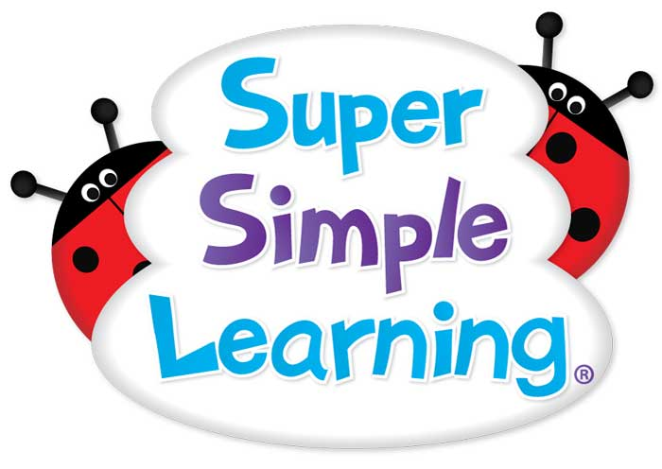 | Enviar el dinero del agua.  Gracias  
Have a Great Week!

